|  |
| --- |
| Evalueserve – Quality Assurance Activities & Artifacts |
|  |
|  |
| 15 /06 / 2017 |

Contents

1. Introduction 3

2. Testing Strategy 4

2.1 Functional Testing 4

2.1.1 Manual testing 4

2.1.2 Automation testing 4

2.2 Non Functional testing 5

2.2.1 Performance Testing 5

2.2.2 Security Testing 6

Introduction

This document provides details on testing strategies and plan adopted during entire testing process required for the project.

The document provides a brief overview and does not include detailed testing processes, technical specifications, engineering or algorithmic expressions or IT backend processes.

Testing Strategy

The Test Strategy is normally derived from the Business Requirement Specification document. It defines the “Software Testing Approach” to achieve testing objectives.

## Functional Testing

QA team follows a multi-step Quality Assurance (QA) process to ensure the highest level of quality. Our QA process makes sure that functionality suffices the end clients’ requirements.

Functional testing comprises of both Manual & automation testing

## Manual testing

* QA team prepares the sub-system test cases on the basis of business rules provided in the BRD.
* After completion of sub-systems testing, a separate iteration is carried out to perform integration testing of the sub-systems.
* After the completion of sub-system/System testing and QA phase, the sub-system/ system is configured for system acceptance test.

**Test Suite sample:**



## Automation testing

Automation adds efficiency to the testing process by leveraging test automation tools that can quickly run through test cases and report any unexpected results. The identified test cases/scenarios which are required in Regression suite to execute manually on each build/ change request release are converted into automation scripts. These are executed every time a new build comes to test if previous functionalities of application are working fine.

**Framework & Technique**

QA team uses open source tool “Selenium Web driver 3.0” where Data Driven Framework with ‘Page Object Model’ approach is followed. This is a scalable framework where we can add the test scripts of further developments & functionalities of applications. Hence maintenance of script is possible and easily manageable.

**Sample Automation Report:**

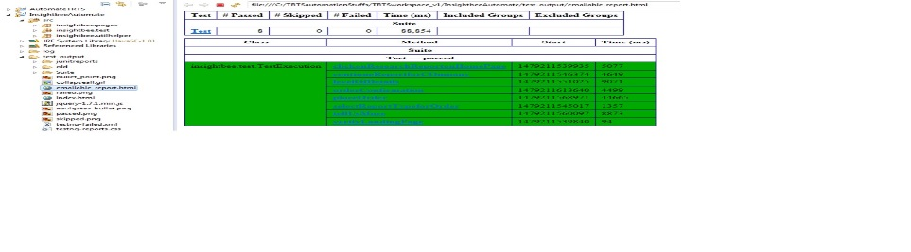

## Non Functional testing

To address the Non-functional requirements QA team carry out **Performance test** to check and fine tune system response time & **Security tests** are performed to determine if an information system protects data and maintains functionality as intended.

## Performance Testing

QA Team conducts performance testing to determine how fast some aspect of system performs under particular work load. Team conducts following types of performance testing:-

Load testing

This type of testing identifies the maximum capacity of Software and its behavior at peak time. For Load testing team uses automated tools such as Apache JMeter, Perf Mon Counters & Web load. The quantity of users can be increased or decreased concurrently or incrementally based upon the requirements.

**Sample Report:**



Stress testing

In this testing team tests the software under abnormal conditions. Taking away the resources, applying load beyond the actual load limit. The main intent is to test the Software by applying the load to the system and taking over the resources used by the Software to identify the breaking point.



## Security Testing

Functional Test plan created by QA team comprises of test scenarios pertaining to security testing like SQL injection, Cross site scripting, Directory traversal etc. depending on application architecture. These test cases are executed during the functional testing round.

**Sample Report:**



The application undergoes vulnerability assessment [commonly termed as Vulnerability Assessment and Penetration Testing (VAPT)] during the Regression testing phase.

In VAPT cycle application is tested for common vulnerabilities & OWASP top 10 threats. This cycle is carried out using automated scanning tools like Net sparker, Burp suite.

VAPT assessment is carried out by internal QA team as well as by an identified third party vendor.

**Sample Internal VAPT Report**



**Sample External VAPT Report**



**----------------------------------------------------------------------------------------------------------------**